* Install Snort

* After installing verify snort

* Create required files and directory if needed

# mkdir /etc/snort

# mkdir /etc/snort/rules

# mkdir /var/log/snort

* Create snort conf rule

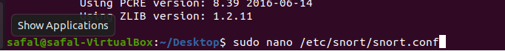

* Create icmp rule



* Execute snort, AS we have not used eth0 port and ensp03



* Start attack from kali linux

* Configure in wireshark if the packets are sent

* Verify the IDS

We can see that detection can be seen.

**For SynAttack**

In your defending machine i.e, Ubuntu

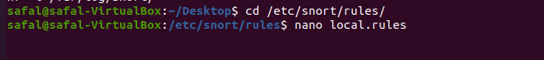

* To validate the configuration

Add your IP address

Then

Now in attacking machine

Monitoring in Defending machine

In this class I had learned about SNORT and how it is used in the real life. The key learnings were to monitor the traffic in Wireshark. There was two virtual machines and we attacked one virtual machine using SNORT and we monitored the traffic using Wireshark. Both of the machines were on a same router so, it was not that easy. The main challenge was to configure the snort and preview how it worked as we had never used SNORT before. We did sync flood attack that time. So, the challenge was to find out if there was any attack happening on the defending machine and to check it as it was a bit hard to setup this thing and get the hold of this scenarios.